# **Brandon Hogue**

**Research Notes**

**Senior Design 1 – ECEN4013**

**Team 2 – The Omega Blade**

**Team role – IR transmission, receiving, sound**

# IR Receiver:

Based upon my research, the following are options for the receiving of IR transmissions:

* Photodiode
* Phototransistor
* IR receiver module **(preferred)**

## Photodiode

While a photodiode (typically reversed biased) will detect IR, it’s largely a proportional relationship between photons received and current/voltage response. This linear relation could cause issues with range and data integrity. This solution does not provide for demodulation of the IR transmission.

## Phototransistor

A phototransistor is based upon the photovoltaic response of a photodiode, but is connected to a transistor, providing gain for the signal, allowing small signals to be amplified to a usable level. While this is better than the photodiode, it does not provide for demodulation of the IR transmission.

## IR Module

IR modules contain a photodiode, filter, demodulator, and amplification in one product. IR modules are purchased for a specific carrier frequency (e.g. 33 kHz, 56 kHz) and abstract the modulation from the microcontroller, by passing a decoded output to the microcontroller.

The considerations in choosing an IR receiver module are:

* Input voltage
* Current consumption
* Carrier frequency
* Viewing angle
* Sensitivity
* Packaging
* Spectral sensitivity at a given wavelength (940 nm ideal to match IR LED)

Based upon the design parameters and the selection criteria, my research has led me to the Vishay TSOP2xxx and TSOP4xxx line of IR receiver modules. They are available in a convenient through-hole package, and meet our requirements for 56 kHz modulated IR.

The output of the IR module is normally HIGH. If a signal is detected, the IR module will output a LOW. In terms of LED transmission testing,

* LED ON = LOW
* LED OFF = HIGH

Our carrier is 56,000 Hz, which has a period of 17.857143 microseconds. (1/56000).Based upon the requirements in the mage protocol, this implies:

|  |  |  |
| --- | --- | --- |
| Start Envelope | 10 cycle burst | 178.5 microsecond burst |
| Data Envelope | 20-70 cycle burst | 357-1250 microsecond burst |
| Stop Envelope | 150 cycle burst | 2678.5 microsecond burst |
| Max Envelope | 150 cycles | 2678.5 microseconds |

Using an interrupt service routine to check for the start packet, look for and check the two data packets, and detect the stop packet, we can decode the MIRP protocol messages.

The contents of the data packets are as follows:

|  |  |  |
| --- | --- | --- |
| Number of ON cycles | Type of packet | Description |
| 20 | Damage | Does one damage per packet |
| 30 | Healing | Heals for one health per packet |
| 40 | Stun | Stuns the device for 100ms per stun packet |

Since our swords require 360° IR detection, we will require 4 IR modules per blade. The IR module I’ve chosen is the Vishay TSOP34856. This IR module has the following power requirements:

* 5V
* 0.45mA (each) – 1.8mA total

# IR Transmission

## Emitter

Our project requires two different IR emitters, since 3 of our blades much reach no more than 5ft, but one blade must reach 100ft. The easiest way to approach this is to select two IR emitters which are similar in design and power requirements, but differ in optical properties, specifically in angle of emission. This is formally known as Relative Radiant Intensity vs. Angular Displacement.

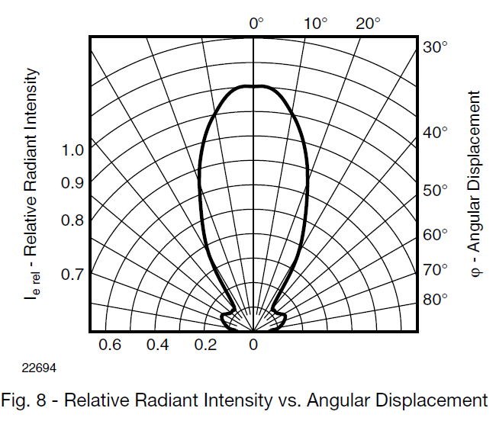

An LED with a wide angle will falloff in intensity sooner than an LED with a narrow angle, as expected. A variety of LED designs will be evaluated based on the following criteria:

* Angular Displacement (emission angle)
* Voltage and current requirement
* Intensity (mW/Sr)
* Form-factor
* Wavelength (940nm required)

I’ve selected the OSRAM SFH4545 10° and OSRAM SFH4547 60° LEDs for our blades. They are 1.35V forward voltage, 100mA continuous-rated 940nm LEDs. They are 5mm through-hole LEDs, and should provide ease of attachment and connection in our project.

The short range blade will contain a single 60° LED, while the long range blade will contain one to three 10° LEDs, depending on prototyping and experimentation.

## Driver

The microcontroller must control the LED, and preferably provide hardware PWM at the specified 50% duty cycle at 56,000 kHz. Since the IR LED(s) will draw far too much current for a µ-controller output pin, an external method of driving the LED must be utilized.

The following solutions were considered:

* N-channel logic level MOSFET
* NPN BJT transistor **(preferred)**

### MOSFET

Based upon my research, I believe an N-MOSFET would be suitable to drive the LED at the required frequency and current level.

The MOSFET must meet the following criteria:

* Must be logic level (e.g. Vgs < 3V)
* Must support rapid switching (56 kHz) – Low
* Must be capable of supplying the required forward voltage to the LED(s)
* Must be capable of supplying enough current to the LED(s)
* Must be operable at 5V (Vds)

Based upon this criteria, I have researched several suitable MOS devices, and have found the Vishay IRL110 to be suitable.

It has a logic-level gate drive, supplies up to 1 A continuous drain current at a Vgs of 5V, and has a suitable input capacitance and low Rds_on.

### NPN Transistor

An NPN transistor can be easily configured into a constant current driver by biasing the transistor with a Zener or switching diodes. This would provide flexibility to add additional LEDs if needed, provide excellent switching times, and high efficiency as minimal power would be wasted on resistors.

This circuit was designed and simulated in Multisim as shown below:

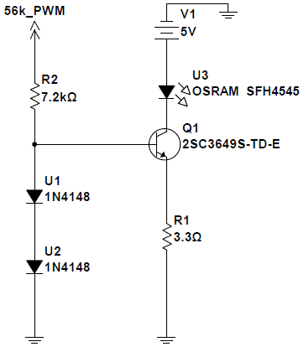

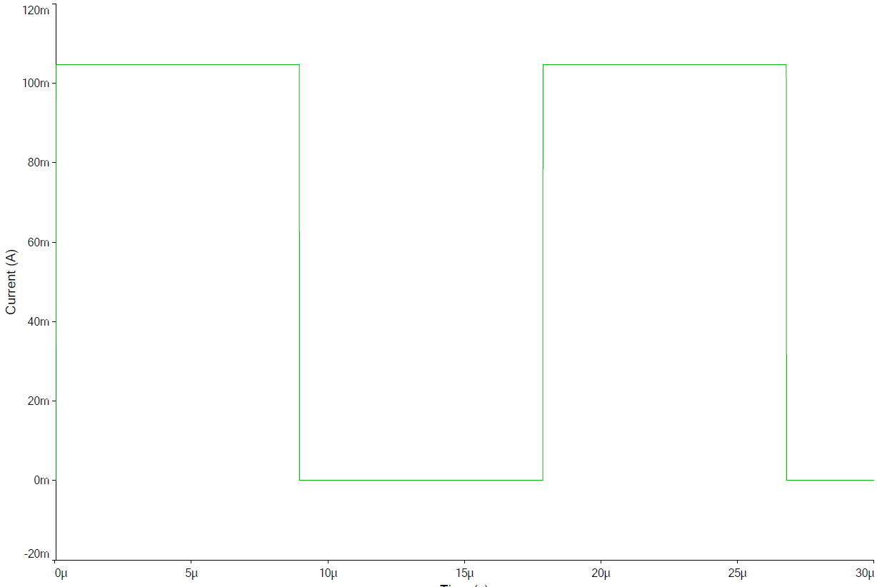

# Sound

There are many solutions for sound, which can be divided into the following categories:

* Breakout board **(preferred)**
* OTP/MTP Sound ICs
* Recordable ICs
* MCU

The tradeoffs of each possible solution are listed below.

### Breakout Board

A breakout board would provide great convenience in integration, save on design time, main PCB real estate, and routing difficulty. Since most support standard MP3, WAV, or OGG encoded audio, transferring audio would be simplified.

Space on the PCB is a considerable constraint due to the form factor of a sword, therefore a breakout board, such as the WTV020SD would be ideal.

The WTV020SD features the following:

* Supports 4-bit ADPCM (.ad4) file formats with sampling rates from 6 KHz to 36 KHz.
* Two operation modes:
  + Serial Mode: Supports a 2-Wire (Data, Clock) interface to any micro-controller
  + Key Mode: Supports a simple standalone operation without a host micro
* Differential 2 line PWM output for direct speaker connection (8 Ohm/0.5W)
* Dedicated 16-bit DAC/PWM audio output to use with an external amplifier
* On-board micro-SD memory card adapter for storing of audio, voice and music files (up to 512 files)
* Supports 64Mb to 2Gig micro-SD memory cards (FAT format)
* Low Power Idle current of 8.0uA

### OTP/MTP Sound ICs

One Time Programmable / Multiple Time Programmable audio ICs provide a single chip audio playback solution, often with a very low pin count. However, they must be programmed with a specialized proprietary programmer, which often cost upwards of $200. This makes this solution cost prohibitive for our project.

### Recordable ICs

Recordable ICs offer a convenient single chip solution, and are available in a variety of storage capacities, sampling/playback rates, and pin-counts. They are available in SPI, I2C, and push-button addressing modes. This is a viable solution. The disadvantage is a relatively high pin count, and subsequently a large footprint. This high pin count also complicates routing, and takes PCB space, which is already at a premium.

Based upon the criteria and design constraints, the APlus aPR2060 would be an acceptable option. It is available in a SOIC 20 or DIP 20 package.This IC supports up to 4 sounds, and they are played by grounding the appropriate select line. Since the MCU output lines are normally low, a 4 input inverter could be used if startup becomes an issue, where the sound IC detects a low before the output MCU pins can be driven ‘normally high’.

### MCU

Several MCU solutions have been evaluated, including using the main MCU for sound generation. Using the primary MCU for audio would likely be rife with trouble, since it will be interrupted by IR reception.

A secondary MCU, such as the Atmel ATTiny86 have been used for sound generation by others, but require a specific library which has a high development overhead. As such, a pure hardware based solution is preferable.